THE CITY OF AUSTIN, TEXAS AUSTIN ENERGY

VICE PRESIDENT POWER
PRODUCTION

The City of Austin is seeking a progressive, knowledgeable and highly qualified utility professional to serve in the executive level role of Vice President of Power Production for Austin Energy – the eighth largest public power utility in the country.

The Position
The chosen candidate reports to the Chief Operating Officer and is responsible for oversight of Austin Energy’s Power Production operations. The position is responsible for oversight of the managers and staff engaged in daily management and operation of two natural gas plants, and management oversight of jointly owned nuclear and coal plants. The successful candidate will be expected to provide the necessary leadership to effectively manage the operations to be safe, compliant, highly competitive and reliable. They will also lead any generation construction and/or decommissioning activities that the utility may undertake to achieve AE’s strategic resource plan. The successful candidate will be expected to be current and engaged in all relevant regulatory and market policy changes and be able to adjust operations strategies to fit dynamic conditions.
The Vice President, Power Production, supervises four direct reports, two power plant managers, the director of Engineering and Technical Services, and the Director of Project and Asset Management, with a total of 120 employees. The Vice President will also serve on the Management Committee for the Fayette Power Plant jointly owned with LCRA.
Challenges include maintaining high reliability with aging assets, managing costs in a low-margin market and developing talent with a workforce that is turning over due to retirement eligibility. This talented individual will help set the direction to continue Austin Energy’s reputation as one of the leading sustainable utilities in the country, as well as meeting the challenges facing the sector including affordability, air emissions, water management, and regulatory changes.

Qualifications
Potential candidates must have graduated from an accredited four-year college or university with major coursework in Engineering, Business or in a field related to the job, plus seven (7) years of related electric utility experience, five (5) of which were in a managerial capacity. A master’s degree may substitute for two (2) years of the required experience up to a maximum of two (2) years.

The Ideal Candidate
With a strategy to retain its leadership position as a nationally recognized, sustainably focused utility, Austin Energy is currently challenged to balance a wide spectrum of community input as well as converging issues on the increasing cost of doing business, economic conditions, prudent investment in its existing resources, maintaining competitive rates, regulatory and legislative change, and progressive environmental responsibility. While many communities in the United States have significant divides over the latter topic, the City of Austin is well aligned in its desire to retain environmental responsibility as one of the key parameters in its decision-making process. Along with Austin Energy’s other executives, the next Vice President of Power Production must recognize and balance the importance and delicate nature of representing the community’s broad interests while making prudent business decisions that reward both economic and environmental interests.
Austin Energy seeks a strong leader and manager who is capable of providing collaborative strategic leadership to both internal and external parties and has the business savvy to understand and manage the financial impacts of generation resource decisions in the Electric Reliability Council of Texas (ERCOT) nodal market. The ideal candidate will offer proven experience as a successful leader in a utility organization, quantifiable results in the development and execution of power plant operation and budget plans and strong project management skills requisite to overseeing power plant improvement and construction projects.
It is essential that the Vice President of Power Production understands the impact of change, bring real-world hands-on experience, be a collaborative communicator with strong negotiation skills to forge relationships and be known for positive outcomes. Candidates must understand budgeting, project-management and quality management systems. The ideal candidate must provide strong leadership and direction for senior management and employees with a desire to maintain and enhance a highly responsive, productive, and high-morale workforce.
The Vice President of Power Production, should also offer experience or demonstrate capability for engaging with regulatory parties at the local, regional, state, and federal levels. The Vice President will represent AE at Austin City Council and Commissions meetings and with advisory task forces and environmental groups with regard to generation planning strategies. He or she should be experienced in providing presentations in public and be comfortable engaging with a wide variety of stakeholder interests and topics.

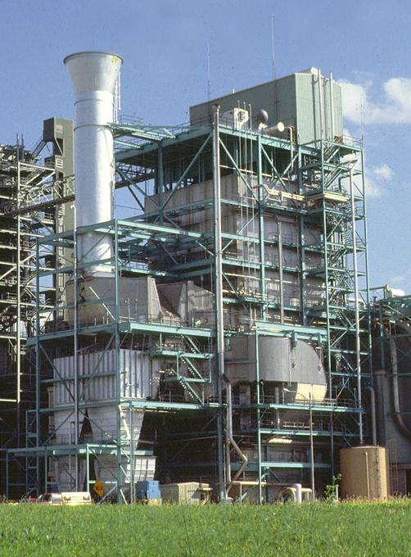
The Vice President, Power Production, should have exemplary communication skills, both written and verbal, and be an experienced, diplomatic negotiator. The interfaces required with regulators, other utilities and peers require that the successful candidate understand and be sensitive and respectful to a broad variety of political, social, and environmental opinions. Politically savvy candidates are highly desired as are candidates with experience in a public utility environment. While public utility experience is not required, candidates from other backgrounds, such as the private utility environment, must recognize and support the public process and the transparent and interactive manner in which leaders at Austin Energy engage their community and employees.

Compensation and Benefits
Salary: Commensurate with excellent benefits and a retirement package. Relocation assistance is provided.

Interested candidates may apply online at www.austincityjobs.org. Please complete the on-line application and attach a resume and cover letter.

Please note: Identity of applicants and interview finalists are subject to public disclosure in accordance with the Texas Public Information Act.

The City of Austin, Texas, is an Equal Opportunity Employer and values diversity at all levels of its workforce.
HOW TO APPLY:
Qualified applicants may apply online via the City of Austin Employment website at https://www.austincityjobs.org/hr/postings/57013
Please include salary requirements in the cover letter.

This position is open until filled; however, the on-line job posting will close on February 17, 2017.

Following this date, applicant information will be offered to those candidates named as finalists, with reference checks, background checks, and academic verification conducted after receiving candidates’ permission.

For more information, please contact Cindy Henson at 512-974-9304 or by email: cindy.henson@austintexas.gov

About Austin Energy

Austin Energy serves a 437 square mile area that includes the City of Austin, portions of Travis and Williamson Counties and several adjoining municipalities. The utility employs about 1,700 people and serves more than 435,000 electric customers; 14% of the customers reside outside the city limits. Austin Energy is the eighth largest public power utility in the United States with over $3.5 billion in assets and over $1 billion in annual revenue. The utility transfers 12% of its revenues to the City’s General Fund.
Austin Energy has exceptional system reliability, a diverse generation portfolio and has been the top utility in the United States for voluntary green power sales for more than a decade and the top public power utility in sales since 2001. Austin Energy also was ranked nationally for its smart-grid development.
The organization’s strong economic and demographic characteristics, competitive retail rates, diverse power supply mix, strong liquidity and history of solid operation earned the utility

consistent rating in recent years: “AA-Stable with with Fitch, Inc.; “A1 Positive” with Moody’s; and “AA Stable” with Standard & Poor’s.
The City of Austin and its City Council are responsible to regulate, monitor, and approve annual budgets, retail rate changes, reliability and customer concerns, as well as generation resource construction, planning, and operations. The Texas Public Utility Commission approves transmission rates and interfaces on reliability and wholesale market issues, along with ERCOT, the state electric grid manager.
Austin Energy’s management team helped the City to develop the Austin Energy Resource, Generation and Climate Protection Plan to 2025. The plan lays out aggressive goals that include a renewable portfolio of 55% renewable generation by 2025 as well as offsetting 900 MW of peak demand through energy efficiency/demand response and several other resource additions and deployments. Austin Energy is a member of the Large Public Power Council and the American Public Power Association.

Austin Energy's Mission:
To safely deliver clean, affordable, reliable energy and excellent customer service.

Austin Energy's Values:
Care and Concern for the Environment, Safety, Innovation, Integrity, Diversity,
Teamwork, Honest, Open Communication

About Austin, Texas

This vibrant and dynamic city tops numerous lists for business, entertainment, and quality of life. One of the country’s most popular, high-profile, sustainable and culturally dynamic cities was selected as the “Best City for the Next Decade (Kiplinger), the “Top Creative Center” in the US (Entrepreneur.com) and #1 on the “On Numbers Economic Index” as the fastest growing economy.
Austin continues to lead the country with its vision of being the “Most livable City in the country,” emerging as a player on the international scene with such events as SXSW, Austin City Limits, Formula I and being home to companies such as Apple, Samsung, Dell, and Seton Healthcare.
From the home of state government and the University of Texas, to the “Live Music Capital of the World” and its growth as a film center, Austin has gained worldwide attention as a hub for education, business, health, entertainment and sustainability. Since 1900, Austin’s population has doubled every 20 years.

The City of Austin is a progressive, dynamic, full-service municipal organization operating under the City-Manager form of government. The Austin City Council has ten council members (one serves as Mayor Pro Tem) and a mayor. The City Council is elected from 10 single-member districts with the mayor elected at large by the voters of the city.
The City Council appoints the City Manager who is the chief administrative and executive officer of the city. The City Manager has responsibilities for guiding and directing day-to-day operations as well as providing strategic research, recommendations, and management leadership to the City Council on budget, programs, policies, and services. The City Manager implements the organization’s administrative responsibilities with a strong team of Assistant City Managers and the Austin Energy General Manager. The City Council and City Manager of Austin are committed to their mission of delivering the highest quality services in the most cost-effective manner. The organization’s vision is to make Austin the most livable city in the country and the City Manager’s resolve is to make it the best-managed city in the country.

